A508-AM,S-Peru-Inca-Figure-Anthropomorphic-Élite-Ceramic1200 CE

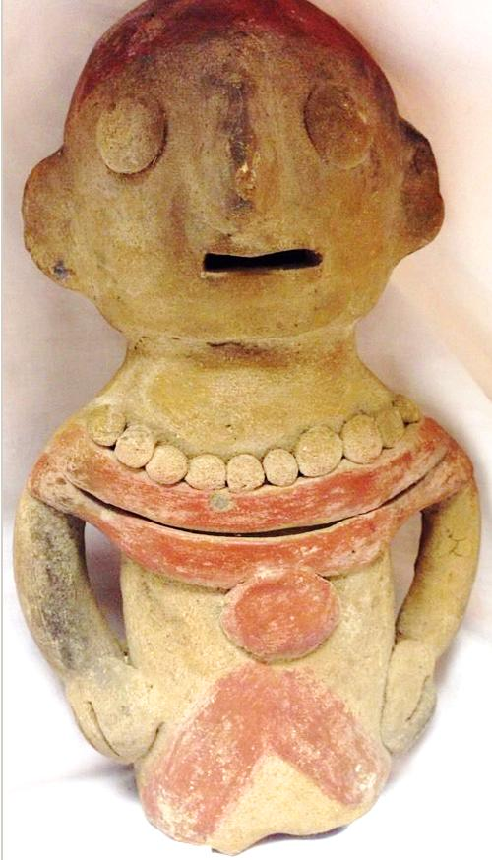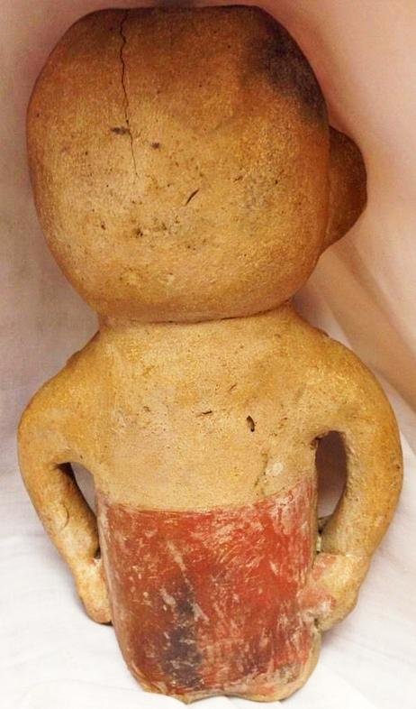

Figs. 1-2. AM,S-Peru-Inca-Figure-Anthropomorphic-Élite-Ceramic1200 CE

Case No.: 10

**Accession No.**

**Formal Label:** AM,S-Peru-Inca-Figure-Anthropomorphic-Élite-Ceramic1200 CE

**Display Description:**

This Inca élite personage wears the full regalia of his office. Originally probably wearing a golden or silver crown or other headgear he now wears a beaded necklace, a gorget suspended by a chest band and a chevron-striped tunic**.**

**LC Classification:**

**Date or Time Horizon:**

**Geographical Area:**

**Map:**

**GPS coordinates:**

**Cultural Affiliation:**

**Media:**

**Dimensions:** 7" high 4" wide

**Weight:**

**Condition:**

**Provenance:**

**Discussion:**

**References:**

**Appendix:**

Additional Views

